Specifications
  - JOME-HOg-0006 Testing Instruction of Part Master Files Available in SR
Doc. Version 01

Customer: | JOSEF MEYER Rail AG
Project: | Testing instruction of part master files visible in SR
proALPHA version:
proALPHA Installation(s): | DE
GUI language: | German
Author: | Ogan Hülya
Created on: | 09.03.2023
Last change on: | 17.06.2026
Contact Customer: | Beat Zumsteg

This document describes a modification or expansion of the standard software proALPHA and has been checked by the customer. The functional design in chapters 2 - 4 is hereby released for technical specification and costing in compliance with the requirements in section "Final Provisions":

......................................................
Date and Signature of Customer

Contents
1. [UPDATE THE TABLE] 3
1.1 [UPDATE THE TABLE] 3
1.2 [UPDATE THE TABLE] 3
1.3 [UPDATE THE TABLE] 3
1.4 [UPDATE THE TABLE] 3
2. [UPDATE THE TABLE] 4
2.1 [UPDATE THE TABLE] 4
2.2 [UPDATE THE TABLE] 4
2.2.1 [UPDATE THE TABLE] 4
2.3 [UPDATE THE TABLE] 4
3. [UPDATE THE TABLE] 5
3.1 [UPDATE THE TABLE] 5
3.2 [UPDATE THE TABLE] 5
4. [UPDATE THE TABLE] 7
4.1 [UPDATE THE TABLE] 7
4.2 [UPDATE THE TABLE] 7
4.3 [UPDATE THE TABLE] 7
5. [UPDATE THE TABLE] 8
5.1 [UPDATE THE TABLE] 8
5.1.1 [UPDATE THE TABLE] 8
5.1.2 [UPDATE THE TABLE] 8
5.1.3 [UPDATE THE TABLE] 8
6. [UPDATE THE TABLE] 9
7. [UPDATE THE TABLE] 10
7.1 [UPDATE THE TABLE] 10
7.2 [UPDATE THE TABLE] 10
8. [UPDATE THE TABLE] 11

Requirements

References
We have the Testing Instruction field on the Production tab in the part master files is to be displayed in the stock receipt.

Summary and Objectives
Value in the testing instruction visible in the stock receipt mask.
ต้องการให้ค่าในฟิล Prüfvorschrift แสดงใน Wareneingangsmaske

Description of requirements
Value in the testing instruction visible in the stock receipt mask.

Term | Explanation
Table 1Requirements Glossary

Functional design

Summary of the Solution

Value in the testing instruction visible in the stock receipt mask.

Description of the solution

Part master files:
Value in the Testing Instruction field
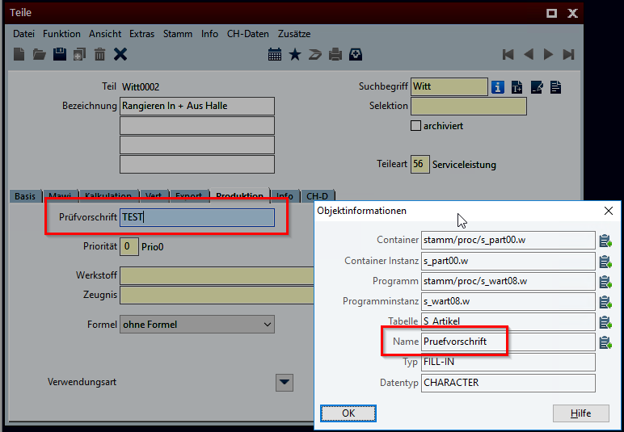
ต้องการให้ใส่ค่าในฟิลด์ Prüfvorschrift ใน Teile (s_wart08.w)

Displayed in the stock receipt mask
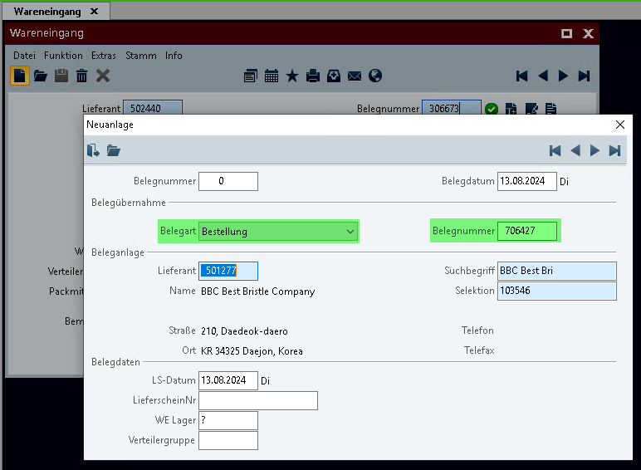

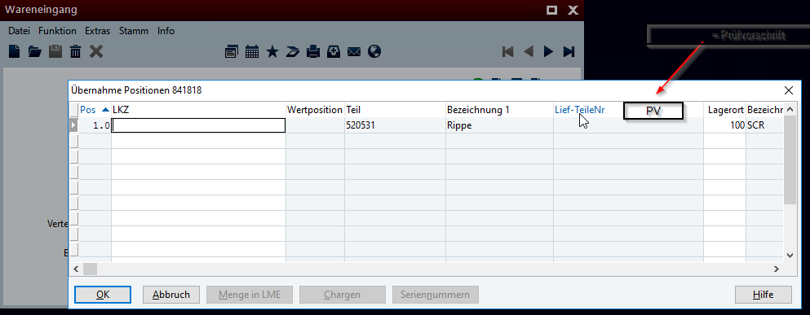
สร้าง Column Brows ใน Wareneingangsmaske เพิ่ม Column ชื่อ PV โดยแสดงค่าจากฟิลด์ Prüfvorschrift ใน Teile (s_wart08.w)

<Template for Section>

Business Logic & GUI

Data Model

Output

Differentiation
The customization refers to the tables, fields and programs mentioned.
These specifications do not automatically add functional extensions to the modules of the proALPHA environment, such as the DMS, Analyzer, reports, and forms. The proALPHA Help is not automatically extended either.
Changes to adjacent modules/programs must be described and defined in the specifications sheet.

Test cases
The specified test cases map the customization described here and are the basis for the acceptance of the software.

<Title of the test case>
Pt | Explanation | Expected result | Test data
 | Test result (incl. screenshots)
 | Test result (incl. screenshots)
 | Test result (incl. screenshots)

<Title of the test case>
Pt | Explanation | Expected result | Test data
 | Test result (incl. screenshots)
 | Test result (incl. screenshots)
 | Test result (incl. screenshots)

Requirements

Technical Requirements
The use of proALPHA functionalities outside the concurrent user model (connection of external systems, background processing) requires the licensing of so-called software services.
"Use of proALPHA functionalities" refers to any use or access to the proALPHA infrastructure, e.g.
- Writing to proALPHA data structures
- Calling proALPHA classes and other business logic
- Opening proALPHA Services
The implementation described in the specifications therefore requires the following software services:
- <Please list services here, otherwise delete section>
- ...

Organizational Requirements

Notes about the go-live

Technical Design

Implementation

GUI

Business Logic

Data Model

Final Provisions
These specifications form the basis for customer-specific extensions of the standard software proALPHA®.
The customer-specific extensions only cover the area defined in this specification sheet. Functionality beyond this scope is not provided.
Unless explicitly agreed otherwise, the customer-specific extensions are only created in German: no programs, program parts or data are translated into other languages. This also applies to the languages supported by ^{proALPHA®} in the standard version.
The customer-specific extensions are thoroughly tested before they are delivered. However, for technical reasons, it is not possible to perform the test under the same conditions and with the same data as the customer will use. It is therefore recommended to carefully check the functions in the real system environment after their delivery.
The Customer is aware that the transfer of the functions defined in this specification sheet to new versions of proALPHA® may require deviations in the display details or handling. This specification sheet also remains valid in this case, provided that there is a maintenance agreement for the customer-specific extensions defined in this specification sheet and no changes to the functionality have to be agreed on.
This specification sheet documents the customer-specific extensions. No other documentation beyond the specifications contained in this specification sheet is to be provided. Questions about customer-specific extensions are received and forwarded by the hotline.
By signing on page 1, you confirm:
that the specification sheet is accepted in this version and becomes part of the contract,
that this specification sheet defines the functional scope of the software to be created and that there are no side agreements regarding the functionality.

Annex

Table of Figures
No entries could be found for a table of figures.

Table of tables
TOC \h \z \c "Tabelle" No entries could be found for a table of figures.

Change History
Doc. -  Version | Date | Specialist | Initiator | Chapter | Explanation
01 |  | Ogan Hülya | Beat Zumsteg | All | Initial new entry

